**Data Representation Document**

**User interface**

Our user interface will be primarily text based with the occasional use of visual data representations and diagrams on pop up windows that can be opened through the Menu of each section.

A house style is to be used to keep a sense of structure in the program making each section seem as part of the whole instead of pasted in separately to the rest.

This is a representation of the layout of the interface.

Average possession

EXIT

Diagrams available through tkinter for all

Derby /rivals stats vs average stats

…

…

Loss vs crime

Main menu.

Final score based on half time score

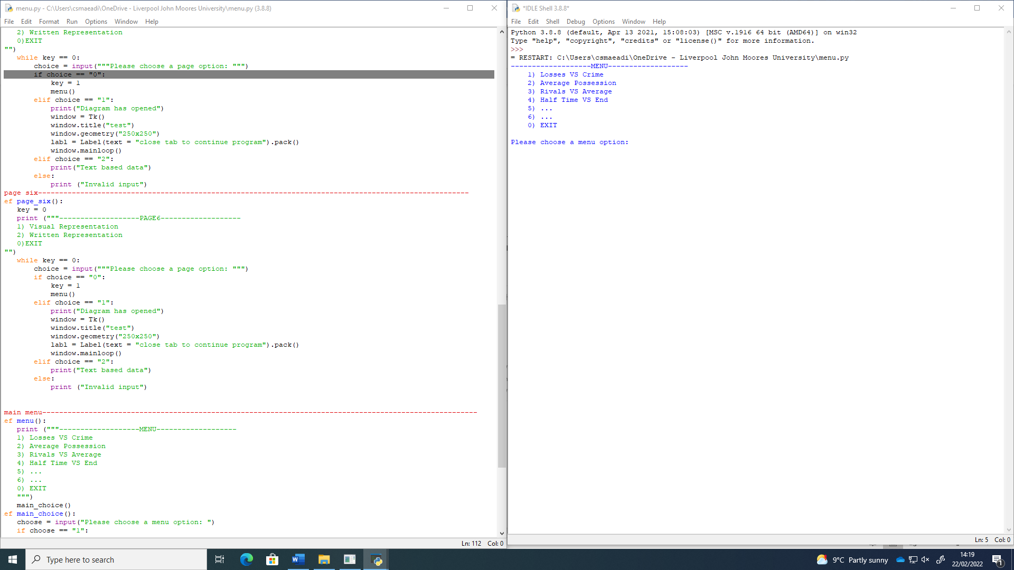

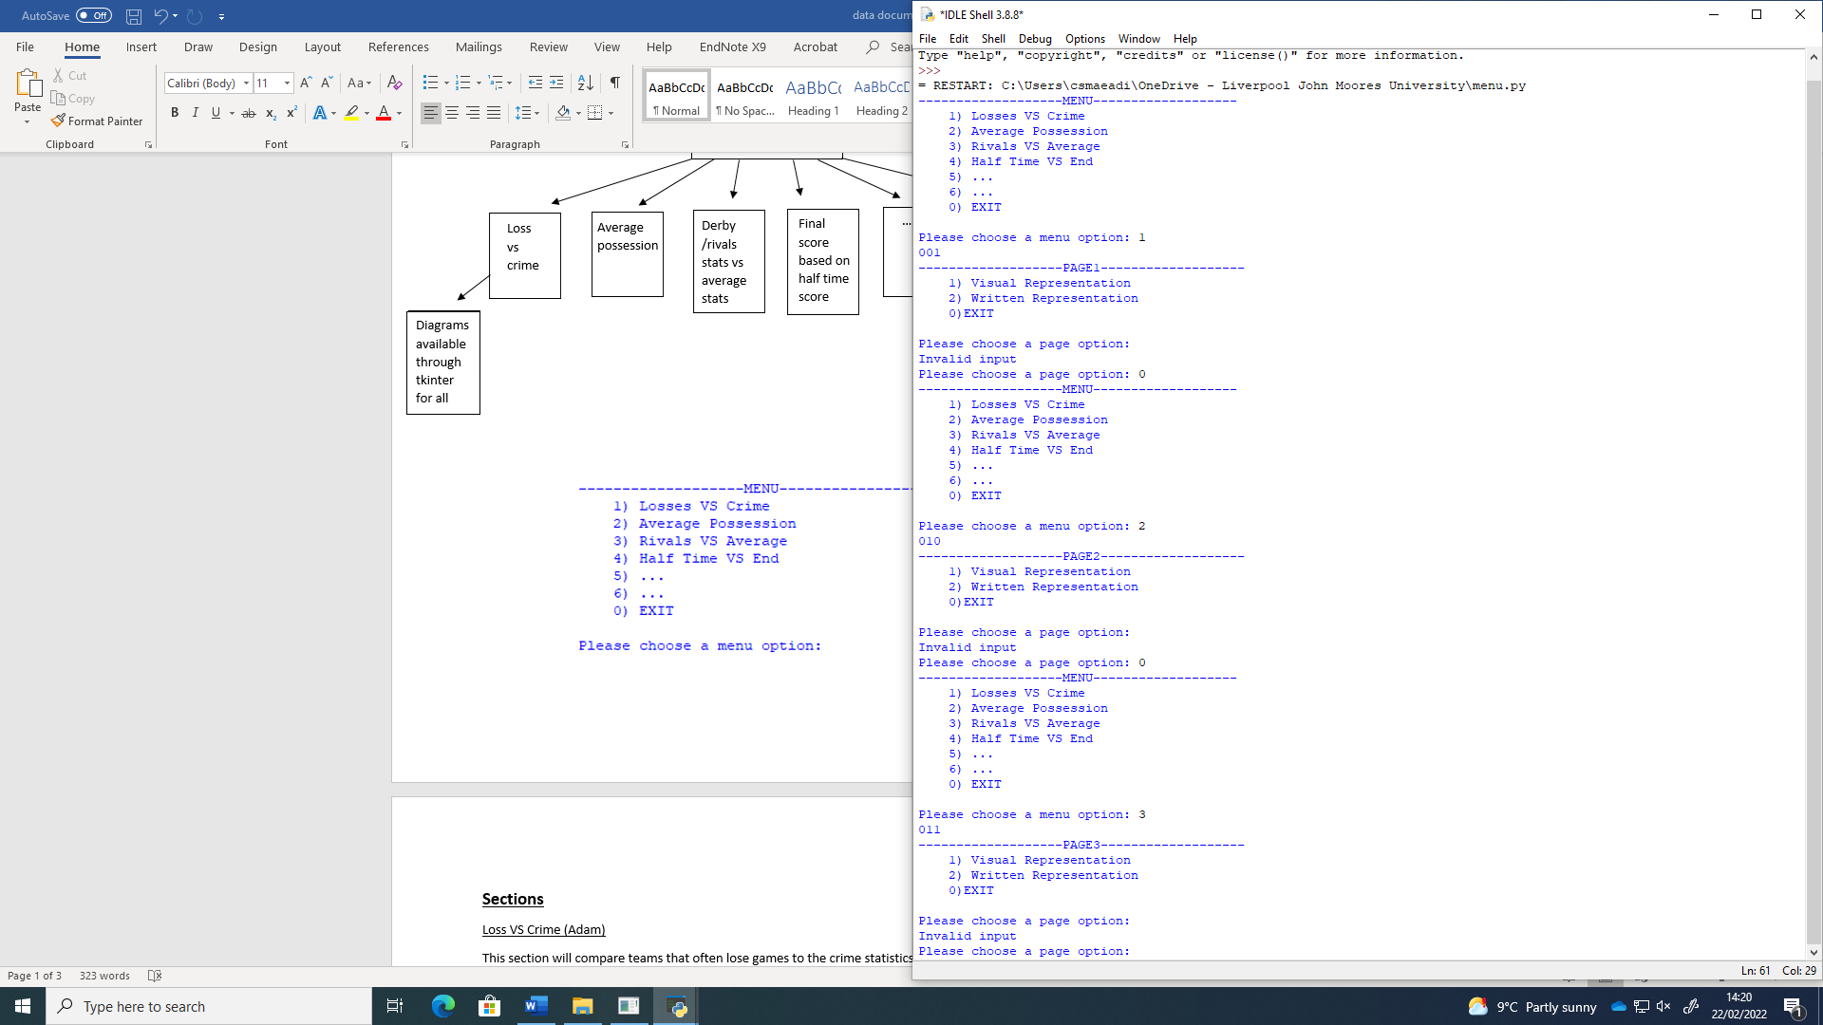

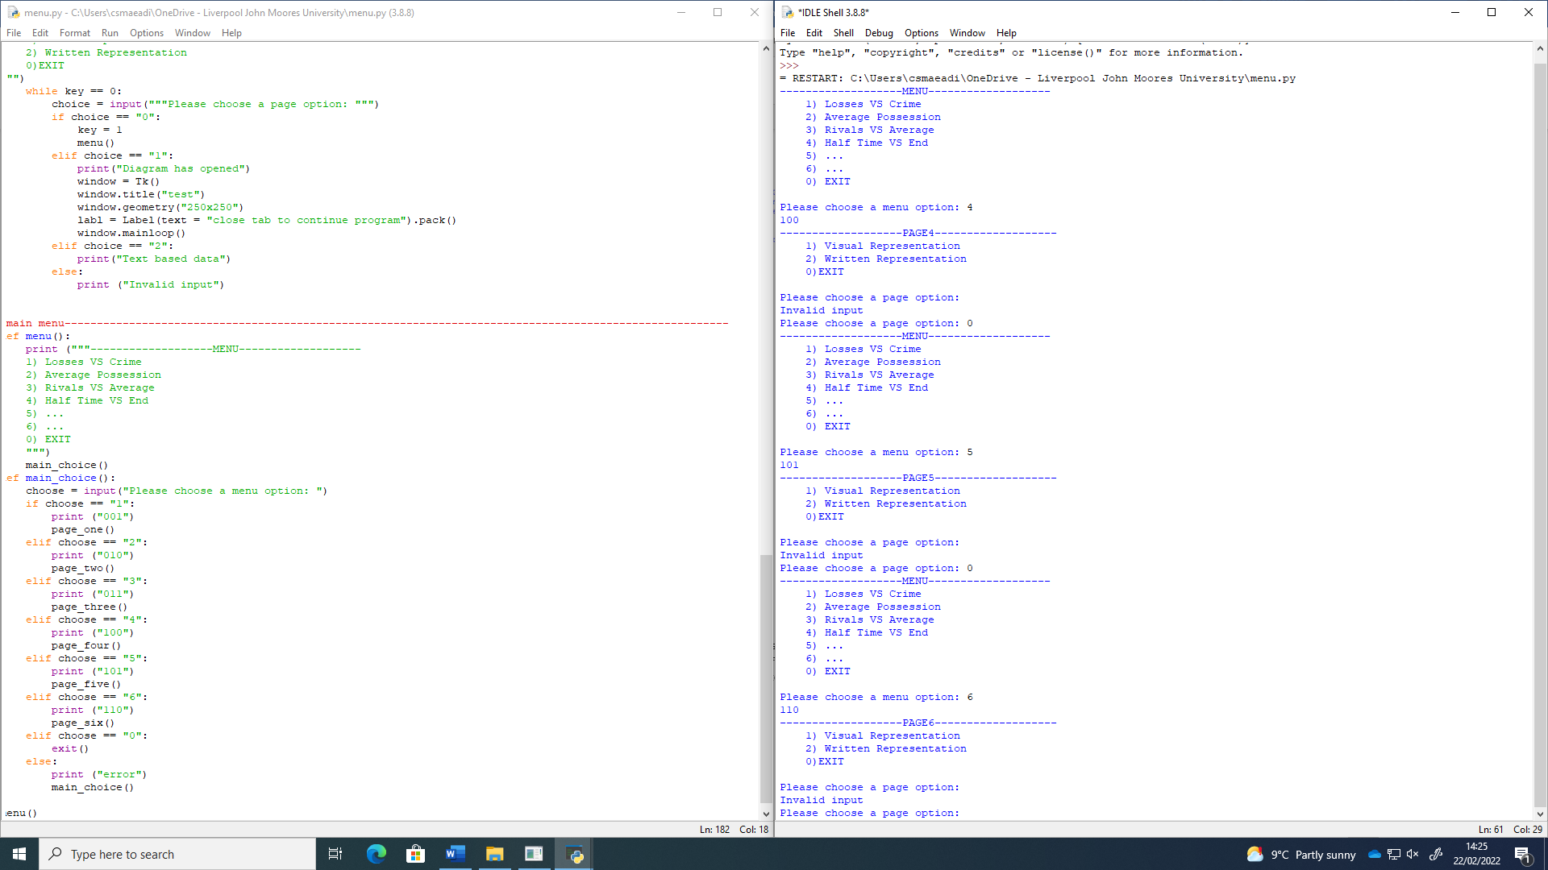



**Sections**

Loss VS Crime (Adam)

This section will compare teams that often lose games to the crime statistics of the area at the time of their matches and whether one factor correlates to the other. In terms of visual representation, a bar chart is probably the most efficient way of showing this aside from written results.

E.g.

Average Possession (Jack)

This section will show average ball possession of each team, highlighting the top and bottom stats. A pie chart could possibly be used for this comparison’s visual component.

E.g.

Derby / Rival Stats VS Average Stats (Ryan)

This section would show the difference in performance against two rival teams and then one of the teams and a random none rival to show how the added history and competitiveness affects the outcome of the match. One possible option for visual representation for this could be a line / scatter graph using a sample of the statistics.

E.g.

Final score based on half time score

This section would compare the score at half time to the end score to see if teams are more or less likely to win depending on their half time score. This could be represented through either a bar chart or pie chart as it has more variables than the others.

E.g.